Update on Communication of Service Disruption Notifications

The college recognizes it is important to communicate service disruptions in variety of ways through variety of communication channels in order to reach the persons impacted within college community as well as visitors to the college. As such Twitter (X) is being used for the first time to complement existing physical signage. Using Twitter (X) for elevator outage notifications is the starting point in expanding the service disruption notification channels.

Please follow the college Security Twitter (X) account for up to date notifications of elevator outages.

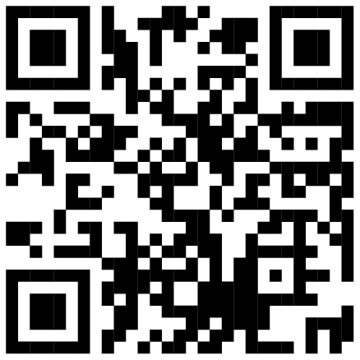
Mohawk College Security Twitter (X)

We are in the process of expanding service disruption notifications channels for all service disruptions and will be communicating updates to the college community as we progress through this process.

We thank you for your continued support and patience in making our college more accessible and inclusive experience for all.

